

Table of Contents

***1 Analysis 2***

**1.1 Introduction 2**

**1.2 Existing products 2**

1.2.1 Microsoft AirSim 2

1.2.2 YSFlight 3

**1.3 Objectives 3**

***2 References 3***

# Analysis

## Introduction

Flight simulators are a genre of program where the user assumes control over an aircraft, such as a plane. Usually, they strive for realism, particularly because they are used to train pilots and other jobs involved in the air industry such as air traffic controllers. From a technical perspective, they present an interesting challenge due to the requirement to render three-dimensional environments and replicate the physics of real aircraft.

In this project, I aim to build a virtual flight simulator from the ground up, focusing on achieving accurate rendering of three-dimensional environments as well as replicating a very basic system of aircraft controls. The project should primarily aim to demonstrate the ability to use mathematics to project environments onto a two-dimensional screen and do so in an effective and optimised manner. Additionally, the program should also function as a learning tool for – primarily amateur or recreational – pilots, and thus possess systems such as measuring the G-force on the cockpit, or the ability to take off/land. These are important as making mistakes while flying a real plane could be potentially dangerous, so it could assist in helping amateurs recognise dangerous manoeuvres.

## Existing products

The following is an analysis of some existing flight simulators:

### **YSFLIGHT**

YS Flight1 is a Flight Simulator written in C++ using OpenGL by Soji Yamakawa, with its first release in 1999, and it has received regular updates ever since.

According to Yamakawa, the program was written for the purposes of *“(1) writing my own flight simulator, and (2) writing a software used by hundreds of thousands of people over the world. I am always so happy to receive encouraging emails about YSFLIGHT.”*2. Initially created as a school project, it was turned into software to help people learn to understand aircraft physics and mechanics: *“Microsoft Flight Simulator is a great piece of work, but I also believe it is nice to have a flight simulator that everyone can casually play during the lunch break. That has been the concept of YSFLIGHT. But, I put many elements that I learned from my flight training in YSFLIGHT. I do use YSFLIGHT for practicing IFR approaches in a Cessna for myself (of course I'm not logging time for it though.) I hope YSFLIGHT serves you well for the future!”2.*

Booting up YS Flight, we are treated to this menu where we choose a starting location and model of plane, among other factors: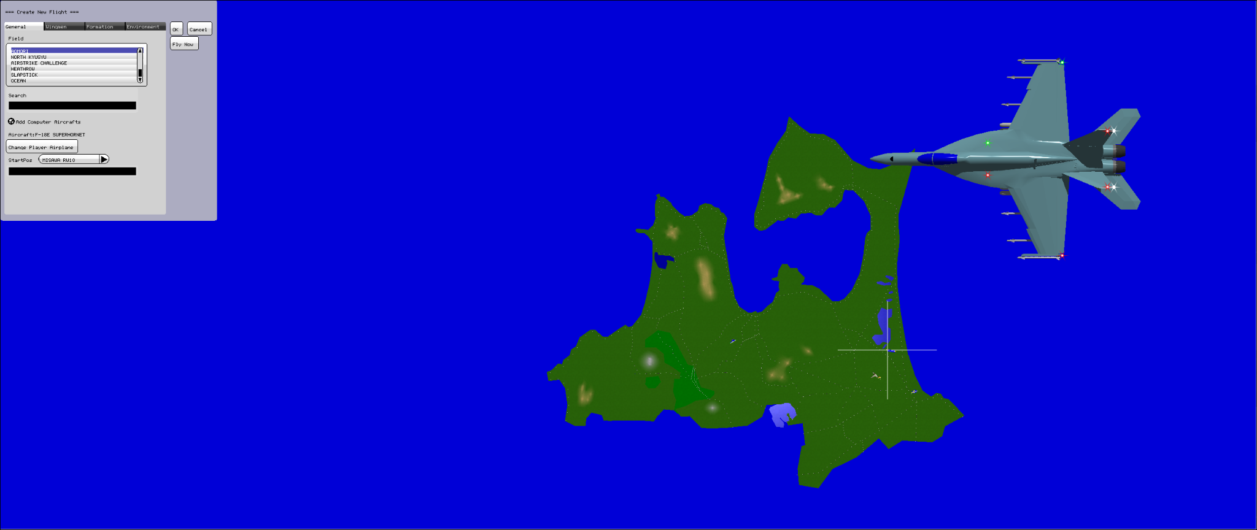

YS Flight is primarily designed for joystick control, however the mouse and keyboard can be used to simulate joystick input. Upon entering the cockpit, several features of the control scheme stand out:

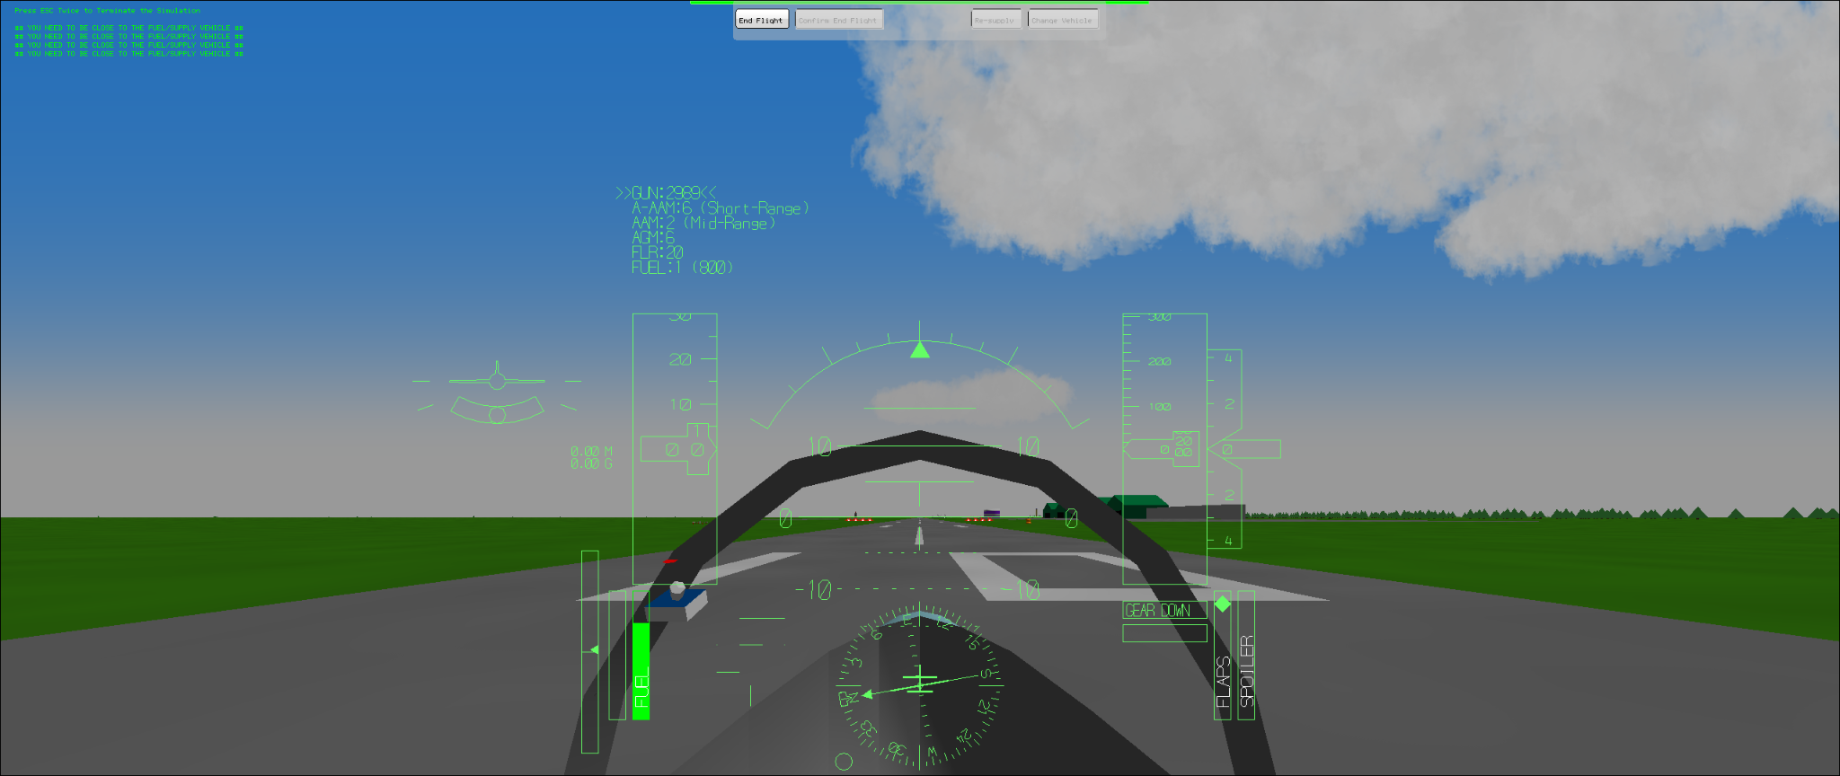

* There is a virtual joystick on screen, seen on the left of the cockpit in the image. This allows the pilot to see the status of the joystick at all times, which is useful for mouse controls
* There are physical flaps and spoiler indicators (bottom right of the UI). These are the controls used on real places, and are responsible for turning motions. Having physical bars showing the orientation of each helps with visibility of the controls substantially.
* There is a virtual plane on the left side of the UI, showing its orientation relative to the ground - this is useful because YS Flight primarily employs a camera perspective from inside the cockpit.
* However, one drawback is that controls aren’t easily explained, and you can’t access them from inside the simulator.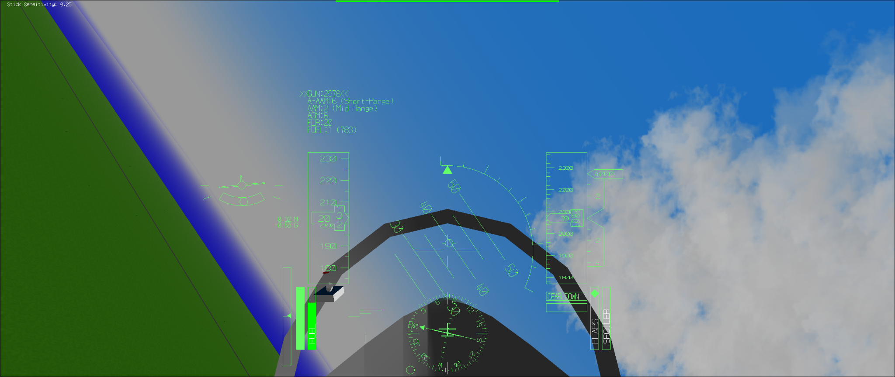

The simulator also contains several pre-built scenarios, such as trying to land a plane at a recreation of London Heathrow. After playing around with the flight controls for an hour, these are some interesting features I noticed:

* As noted in the Introduction, it is important for flight simulators to accurately convey dangerous manoeuvres to teach aspiring pilots in an environment where no risks are posed regarding their safety. YS Flight achieves this by colouring the entire screen red or black when a high G-force is reached, which functions as an easy to read indicator of pilot danger.
* Sideways motion of the joystick controls roll (sideways rotation of the plane) while up/down motion controls pitch (up-down rotation). Yaw, the rotation that corresponds to the direction on the map the plane is facing, is controlled with the ZXC keys (which physically control the “rudder” at the back of the plane).
* Pressing the “M” key reveals a second camera view, behind the cockpit. This is useful in the case of YS Flight since it can be used as a military dogfight simulator in addition to its main use as an amateur flight sim.
* In addition to visual indicators, various bleeps and other noises are used to communicate information to the pilot. These serve as easily recognisable warnings that recommend pilots to look at their gauges - for instance, they might indicate that fuel is not flowing to the engine during a turning manoeuvre due to the forces involved.

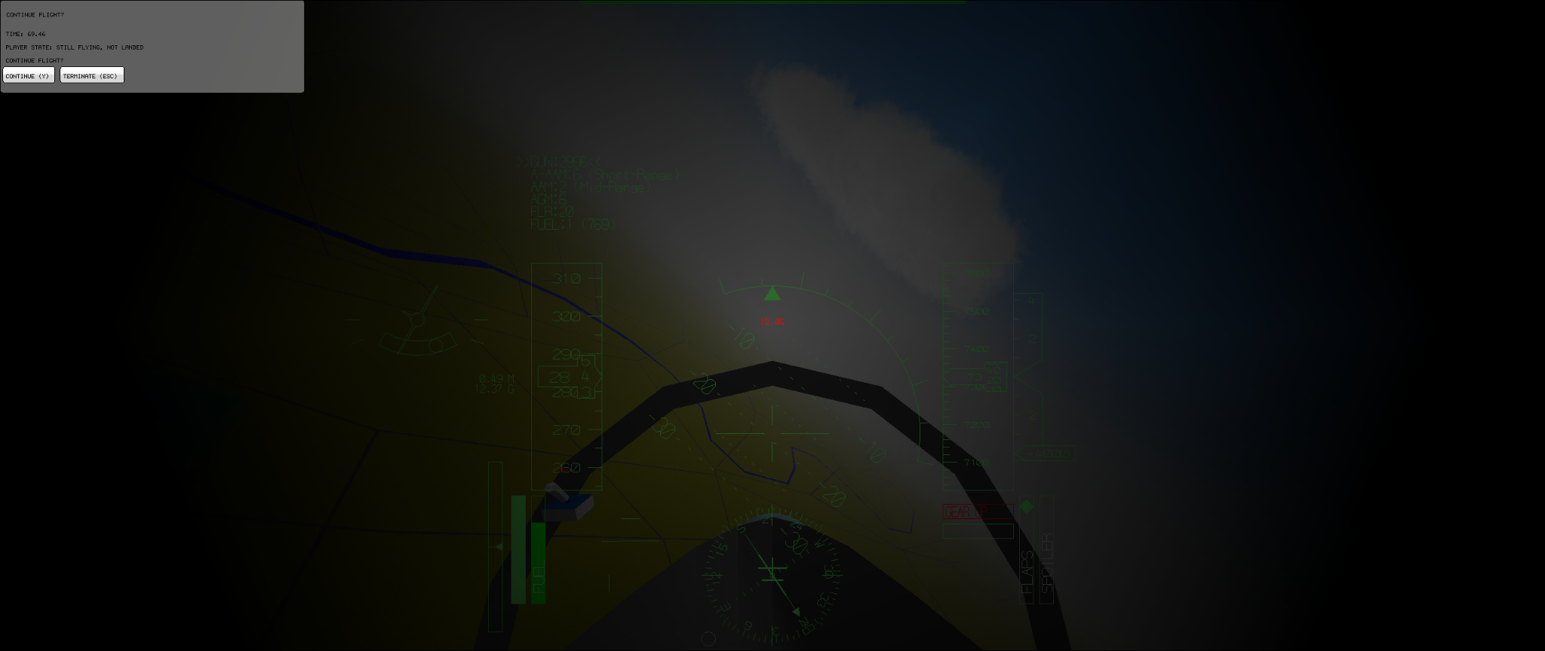

*The screen turns black as I hit 12.4G during a turning manoeuvre, which would be fatal if sustained for more than a second.*

## Objectives

The investigation asks for the following requirements to be satisfied:

1. Store procedurally generated 3d terrain as a mesh.
   1. Generate a Perlin noise map.
   2. From the Perlin noise map, get a set of vertices.
   3. Using the vertices, define triangles (tessellation)
2. Render the terrain on-screen according to the location of the player’s camera, and the direction in which it is pointing.
   1. Determine the vertices within the player’s current viewport.
   2. Use back-face culling technique to minimise the number of faces that must be drawn.
   3. Draw 2D triangles between the on-screen vertices.
   4. Update this process for every frame.
3. Render ‘props’ such as trees on the terrain.
4. Draw the plane model, as defined within the program.
5. Update the plane’s position using its linear velocity, angular velocity and current position.
6. Allow player input, such as the ability to shift the rudder and ailerons in order to perform turning manoeuvres.
7. Compile program to allow for execution.

## Modules

We will make use of the following modules:

* OpenGL3 – OpenGL is a graphics API for rendering vector graphics. This will be the primary method we will use to actually draw what is going onscreen.
* Numba4 – Numba is a python Just in Time compiler. This turns python, traditionally an interpreted language, into a compiled language. The main advantage of this is that it allows python programs to run much faster, which is crucial in graphics processing.

## Prototyping

# References

ANALYSIS:

1 - <https://en.wikipedia.org/wiki/YSFlight>

2 - <https://github.com/captainys/YSFLIGHT>